**Chapter 1 Task**

**Instructions:**

**-Study well and please attach Screen shots from the executable code in addition to sample of queries' results in your Answers.**

**- If you want to know any column name in a specific table you have to apply describe command: desc table_name.**

**-HR schema:**

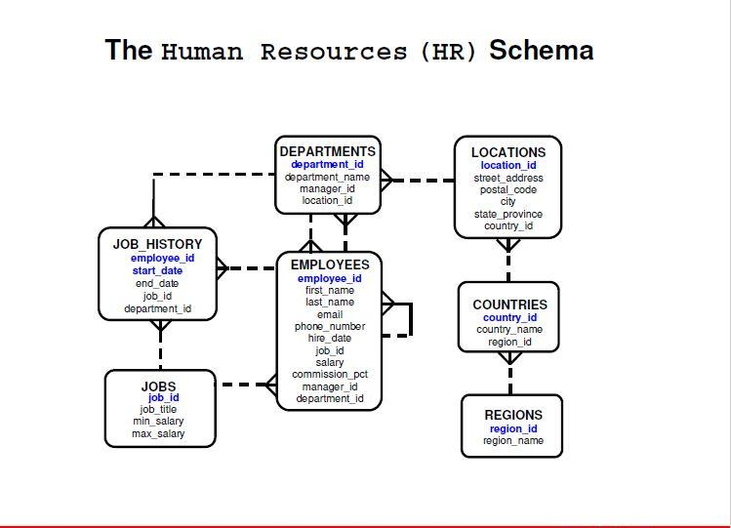

**Display the name concatenated with the job separated by a comma and space and names the column [Employee and Title] for all employees.**

**screenshots**

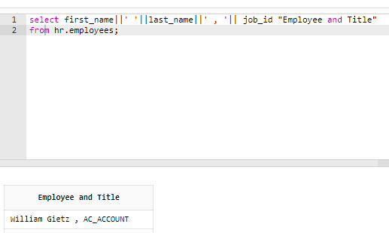

**Display the monthly and annual salary for all employees and rename the columns according to the time-period.**

**screenshots**

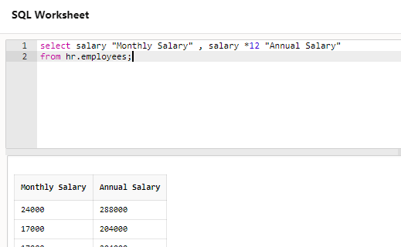

**Display all information about employees.**

**screenshots**

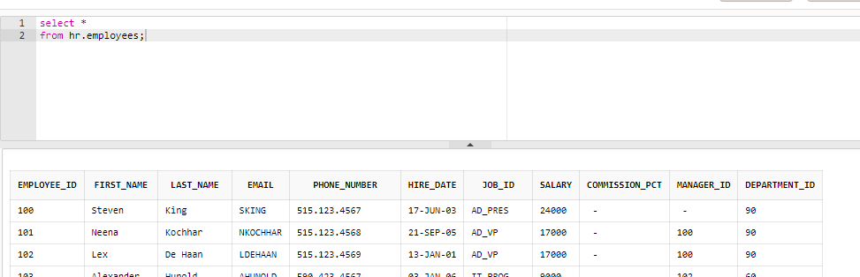

**Display department number and department name for all departments.**

**screenshot  
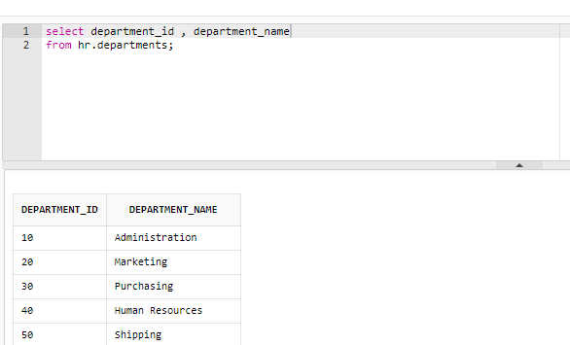**

**Display all information about departments.**

**Screenshot**

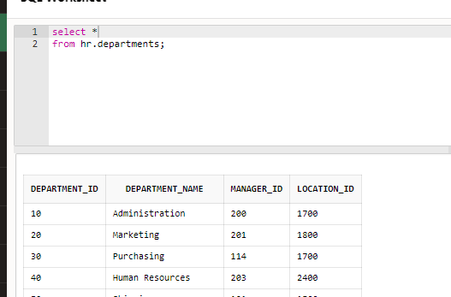

**Display unique salaries which the company offers.**

**Screenshots**

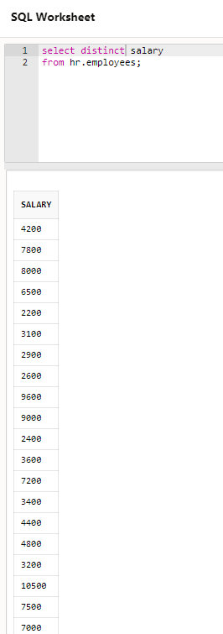

**Display job title, minimum and maximum salaries for all jobs.**

**Screenshots  
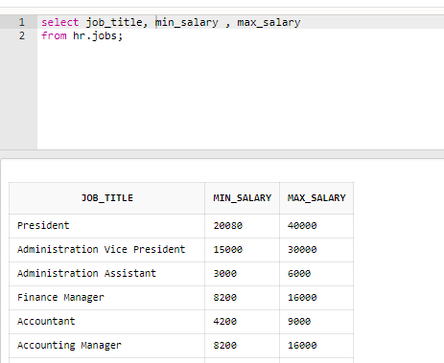**

**For all regions, display region id concatenated with [and its name is] followed by region name and show the output as Regions' details.**

**Screenshots  
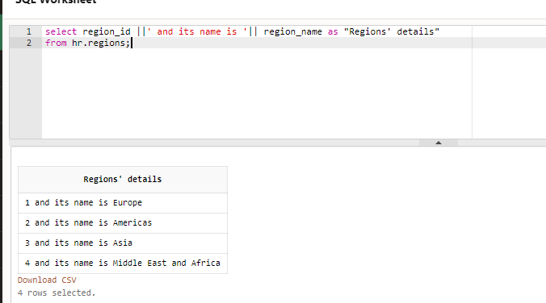**

**Display unique values for both salaries and commissions, what are the numbers of rows in result?—compare that number with the same query but without unique values (check the salary= 4000 and commission=null).**

**Code**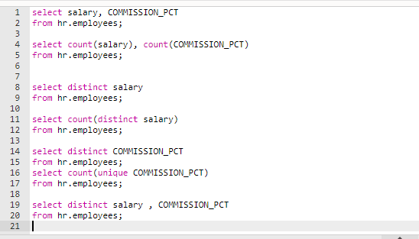  
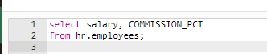**;  
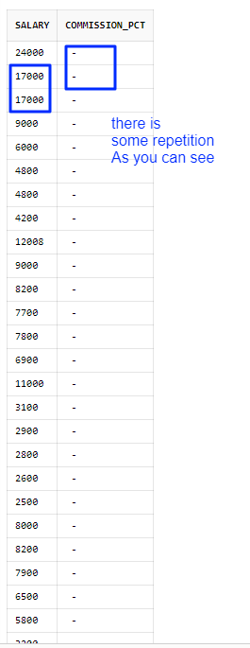**

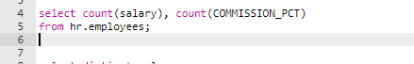 

**  
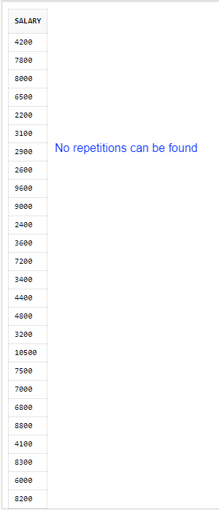**

**  
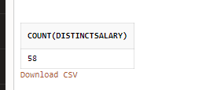**

**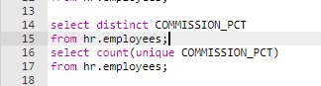  
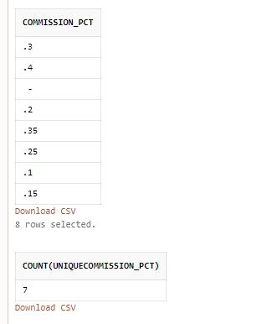**

  
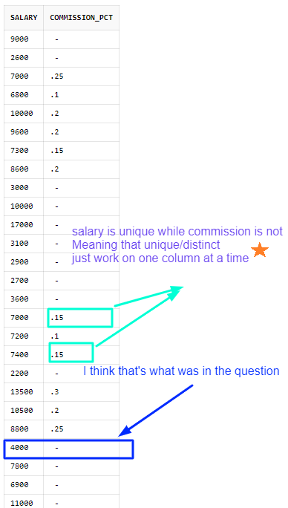

Star  
or it means, for example, that   
4000 / -  
won’t be repeated anymore .. just make the tuple unique

=====================================